Biometric Scanner Setup

# Setup

## Step One – Physical Setup

Two connections, the power cord and the Ethernet cord are required to setup the Biometric Scanner.

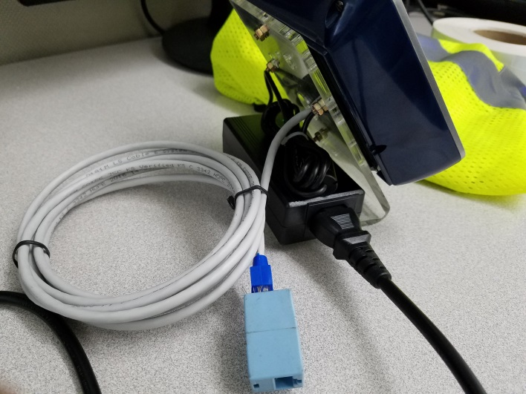

## Step Two – Power-On Device

Connecting the power cord will turn on the device; wait for the boot process to complete.

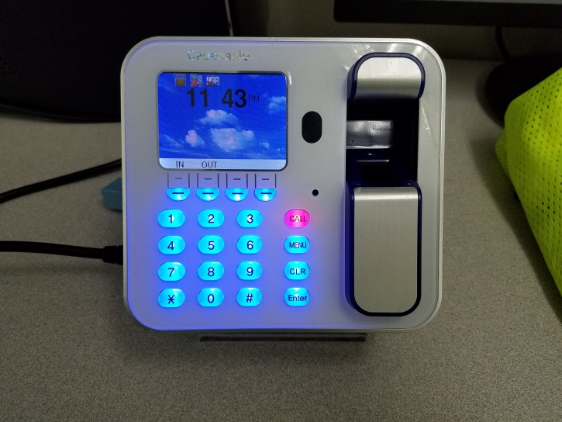

## Step Three – Access the “Administration” Menu

Press the menu button.

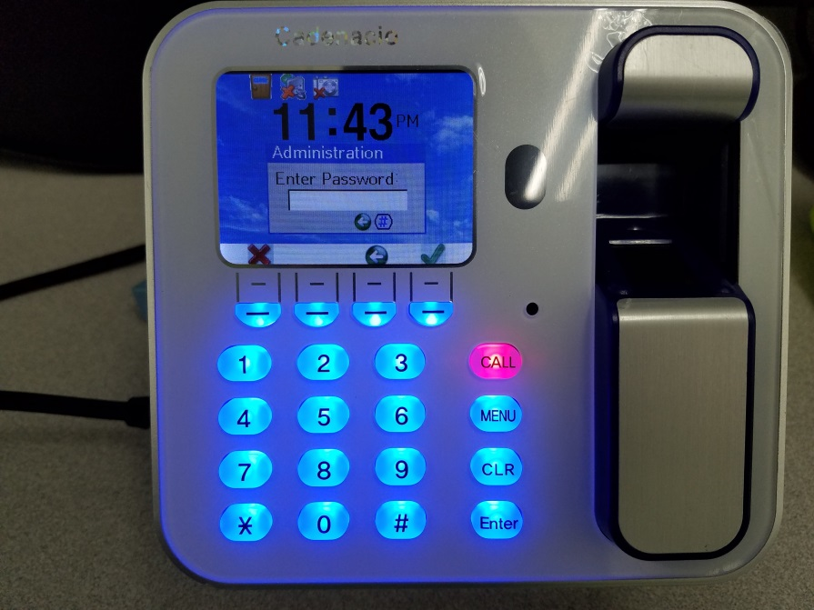

### Enter the Password

1111

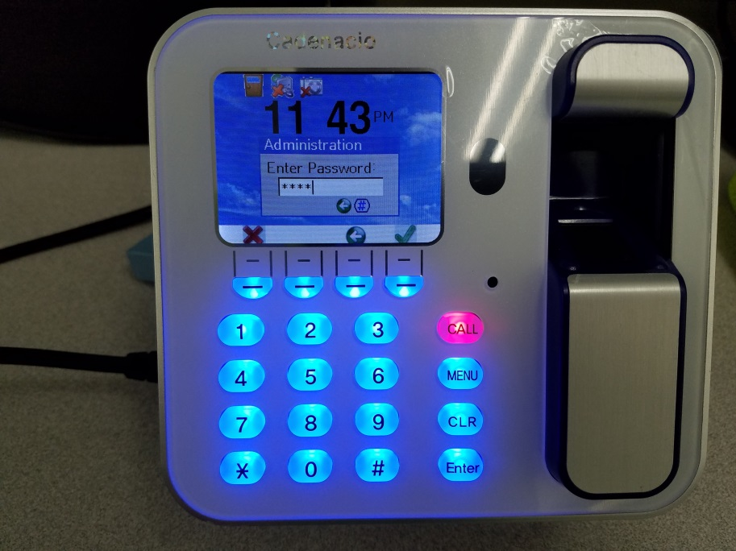

## Step Four – Setup the Network

### Select Option 3 “Network” Options

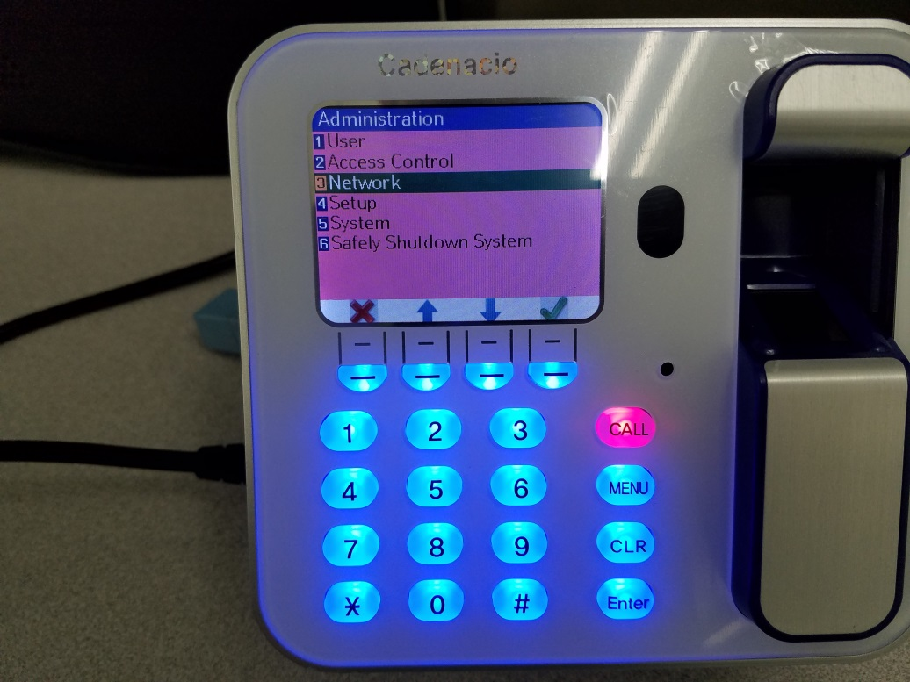

### Select Option 4 – “IP Address”

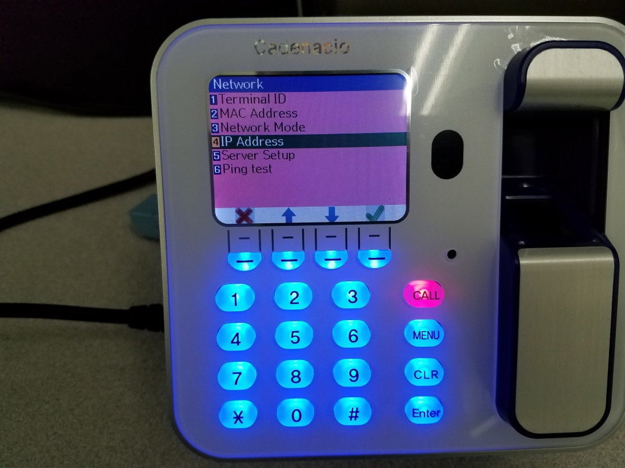

### Select Option 1 – “NO”

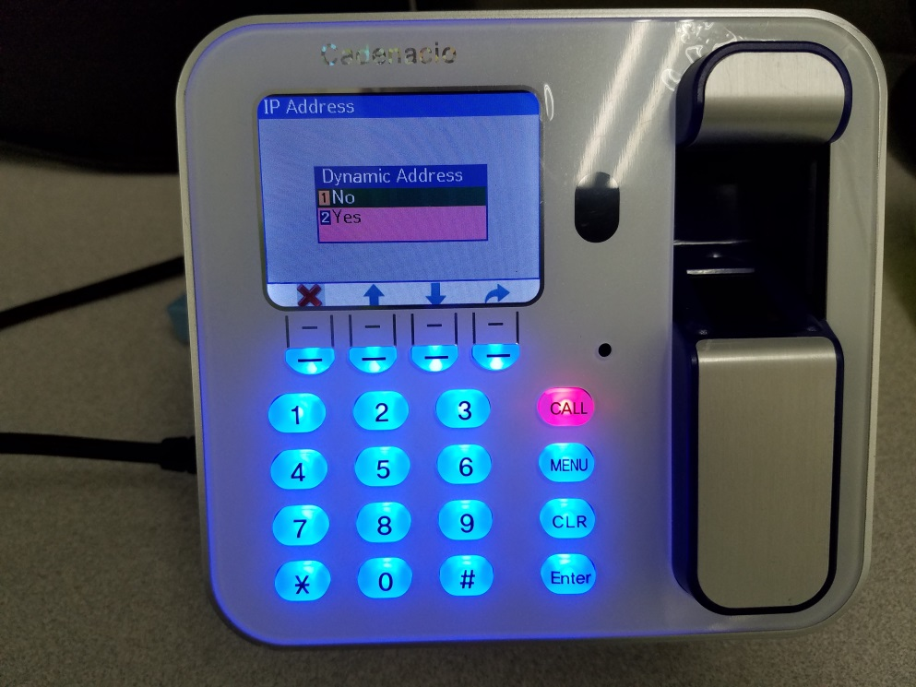

### Set the IP Address Options

* Change the IP Address to the correct address
* Leave the Subnet Mask 255.255.255.0 by DEFAULT
* Change the Gateway to the correct address

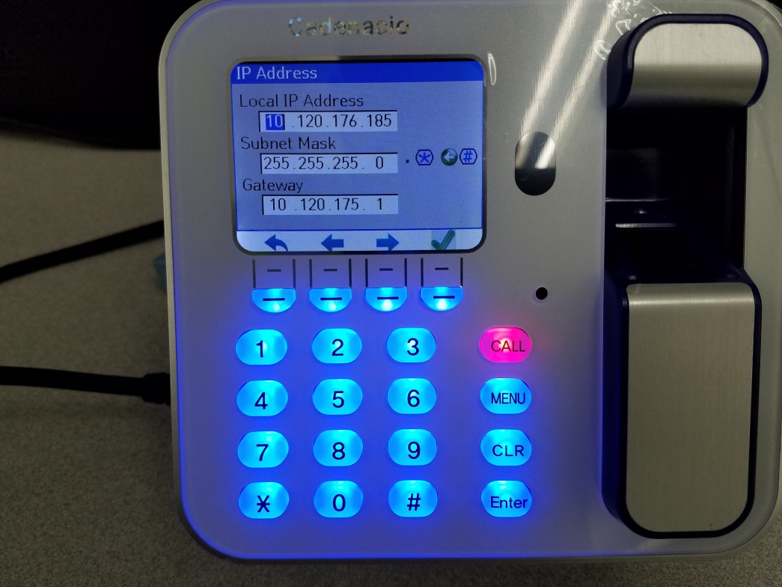

### Select Option 5 – Server Setup

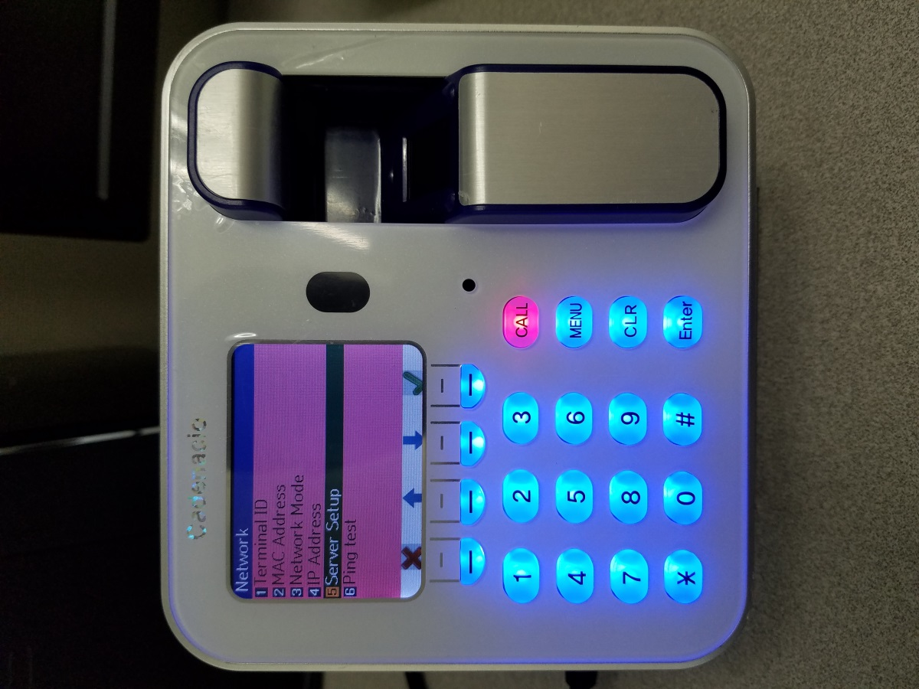

### Setup the Server

* Change the “Server Host” address (All scanners will use the same server host)
* Leave the Server Port to the DEFAULT

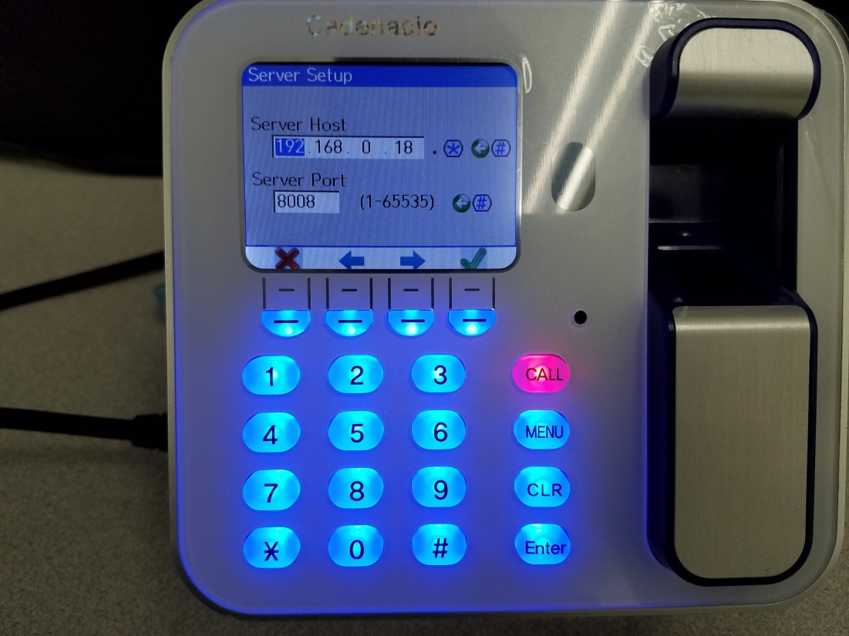

### Select Option 6 – Ping Test

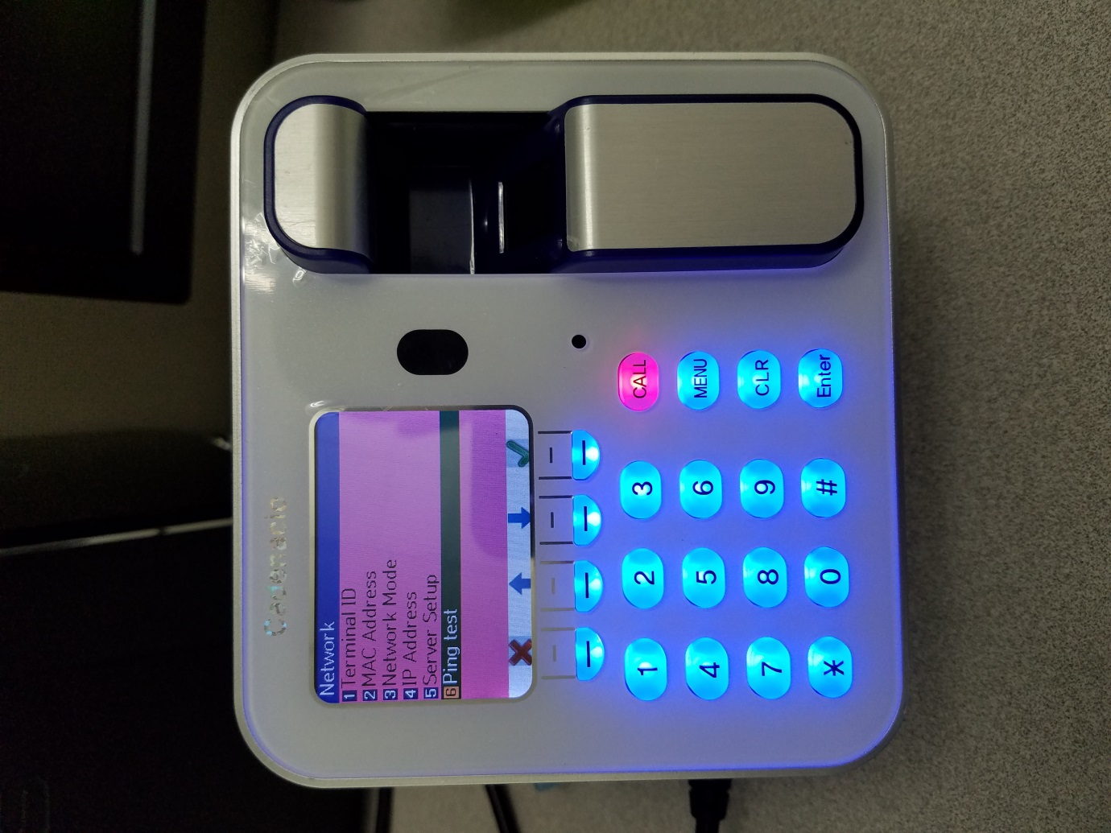

### Ping the IP Address supplied earlier to Test Success or Failure!

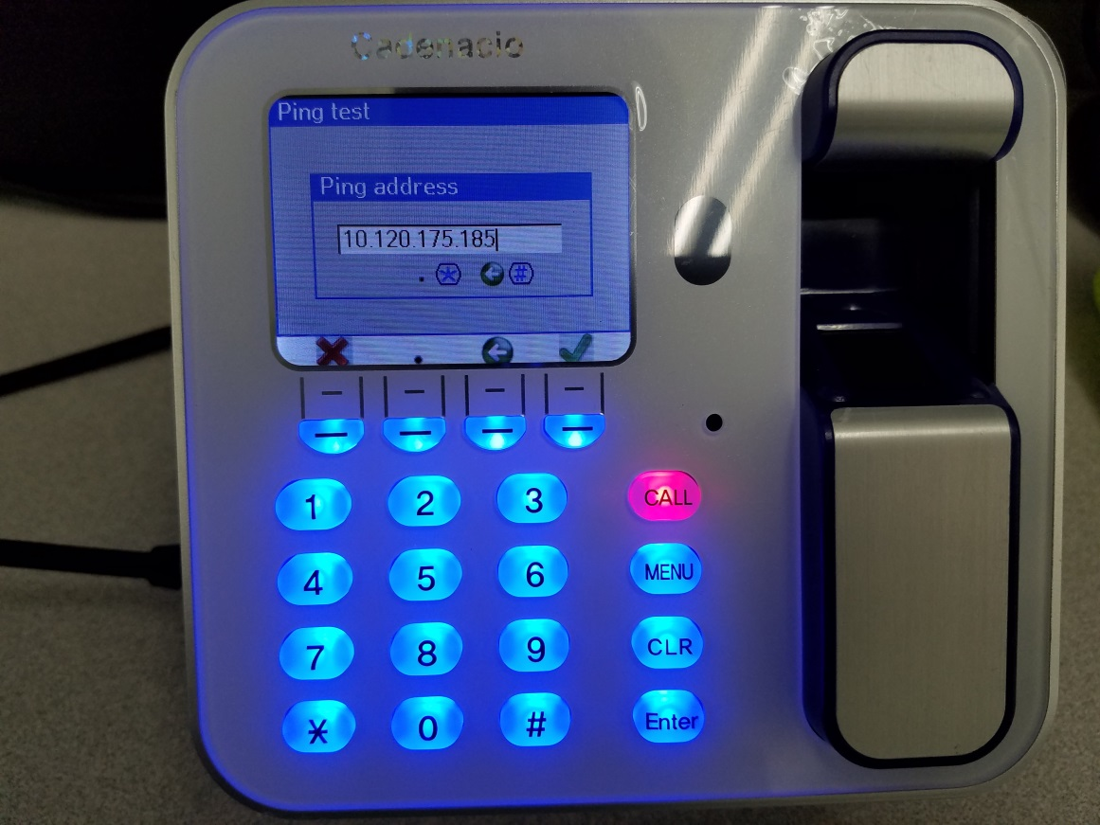

# Reference

## Key *

Use for TAB function

## Key #

Use for BACKSPACE function

## Key - - - -

Dynamic keys that change with the current directory